Representing the transition relation
The transition relation → of a model M = (S, →, L) is a subset of S × S. We have already seen that subsets of a given finite set may be represented as OBDDs by considering the characteristic function of a binary encoding.
Just like in the case of subsets of S, the binary encoding is naturally given by the labelling function L. Since → is a subset of S × S, we need two copies of the boolean vectors. Thus, the link s → s’ is represented by the pair of boolean vectors ((v1, v2,...,vn), (v’ 1, v’ 2,...,v’ n)), where vi is 1 if pi ∈ L(s) and 0 otherwise; and similarly, v’ i is 1 if pi ∈ L(s’ ) and 0 otherwise. As an OBDD, the link is represented by the OBDD for the boolean function
(l1 · l2 · ···· ln) · (l’1 · l’2 · ···· l’n)
and a set of links (for example, the entire relation →) is the OBDD for the + of such formulas.

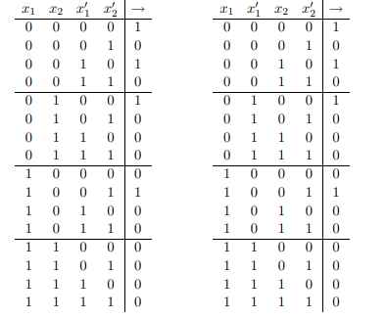
The truth table for the transition relation. The left version shows the ordering of variables
[x1, x2, x’1, x’2], while the right one orders the variables [x1, x’1, x2, x’2] (the rows are ordered lexicographically).

